FEATHER BANNER™ & HD POLE INSTALLATION INSTRUCTIONS

HD POLE FEATHER BANNER™ INSTRUCTIONS
CONGRATULATIONS! You have just discovered the newest and one of the most elegant ways to decorate your planned outdoor weddings, receptions, special events and more. Feather Banners are one of the most effective outdoor promotional and decorating tools available. You will surely want to insure the maximum life of your equipment. The following instructions and suggestions will help you get the most out of your Feather Banners.

ASSEMBLY
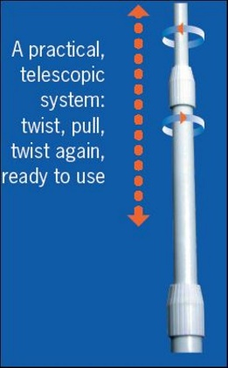
- Pound the ground stake into the ground until it is secure in the desired location. (usually 12 to 18 inches) Always allow 12"-18” exposed on which to place the HD Pole. The mounting stake can also be attached securely to any vertical fence post, bleacher railing, etc. with hose clamps. The location of the stake/banner should allow at least 10 feet of clearance from surrounding objects since the banner will bend and move that much in the wind.
- Fiberglass poles are strong, but they should be handled and treated with care.
  - To extend the pole, unlock by turning the lower locking mechanism counterclockwise half a turn or so, then extend section #2 approximately 48". Lock section #2 in place by turning the locking mechanism clockwise until snug. (DO NOT OVER TIGHTEN)
  - Repeat step 1 for section #3 of the pole then add your extension rod (84" when assembled) to the mushroom looking bushing inserted in the tip of section #3.

- Unfold banner and insert the small tip with the D-Ring eyelet of pole into the bottom sleeve side of the banner that has the Velcro strip sewn inside.. It helps to have someone hold the opposite end of the banner at the end with the short loop of string/swivel clip. Slide the banner over the pole until the pole tip extends out of the banner top end of the sleeve. Use the snap swivel at the top of the banner to attach to the metal D-ring eyelet at the top of the pole. The bottom Velcro should be attached to the adhesive piece of Velcro provided for each pole.

- Together place this assembled feather banner and pole over the ground stake. If there is high wind during this procedure. It is important to do it in one smooth and quick motion.

MAINTENANCE

- Check throughout the day that the banners are not excessively leaning due to soft soil or sand. If so, relocate stake and pound it deeper allowing at least 12 to 18 inches exposed on which to place your banner/pole.
- In certain applications when set up is near buildings, the wind may swirl and cause banner to “wrap” around the pole. Simply “unwrap” and/or relocate.

DISASSEMBLY

- In one smooth quick motion, completely remove the pole from the stake. The quickness is only necessary in high wind situations.
- Disconnect banner from both ends of the pole and neatly fold it. If banner is wet, fold it temporarily. Do not leave it folded wet for more than a few hours. If it is stored wet, mildew will form and certain colors may bleed causing permanent damage.
- Collapse your pole by loosening the locking mechanisms. Repeat this for all sections. Stowe away the pole and extension rods together in the pole carrying case for the next installation.

Be sure to take lots of pictures - you may want to make these a signature item.
Wind Visuals
sales@windvisuals.com 802-233-0853

